Mrs Avilla Dororosa Goba - Profile

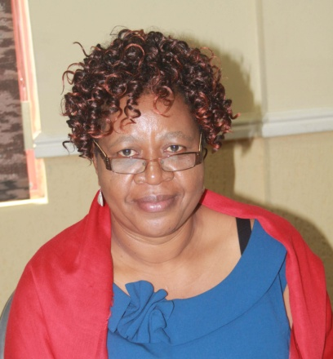

Born in Harare, Zimbabwe. Head Corporate Services for Postal and Telecommunications Regulatory Authority of Zimbabwe (POTRAZ).
Former Human Resources and Administration Manager for Privatization Agency of Zimbabwe. (PAZ). Worked for the Post Office Savings Bank (POSB) under Posts and Telecommunications Corporation (PTC) where I held various posts including Training Manager, Administration and Bank Manager.

Served as Council Member of Bindura University of Science Education (BUSE) for 3 years.

Membership
- The Institute of Bankers Zimbabwe (IOBZ)
- The Human Resources Development and Empowerment committee for the Regulators Association of Southern Africa (CRASA).
- Life member of the Jairosi Jiri association in Zimbabwe. This is an Association for a special group of Children with disabilities.
- Thematic Committee dealing with Corporate Governance in State Owned Enterprises and Parastatals.
- Board member to the Zimbabwe Women’s Resource Centre & Network (ZWRCN) and Chitungwiza Garment Factory.
- Executive Committee Member of the Institute of Chartered Secretaries And Administrators in Zimbabwe (ICSAZ), Marketing and Strategy committee as well as the Nominations Committee.

Academic Qualification: Holds a Master in Business Administration (MBA) degree.

Dissertation Topic - “An assessment of the Impact of Deregulation of the Telecommunication Sector”: The Zimbabwean experience

Professional Qualification: Holds The Institute of Chartered Secretaries and Administrators (ICSAZ) qualification. This is an International qualification in which Zimbabwe is a member. As a Council member, I am a Fellow (FCIS) of the Institute of Chartered Secretaries and Administrators.
Appointed President of the Institute of Chartered Secretaries and Administrators in Zimbabwe for period 2011 to 2012.

