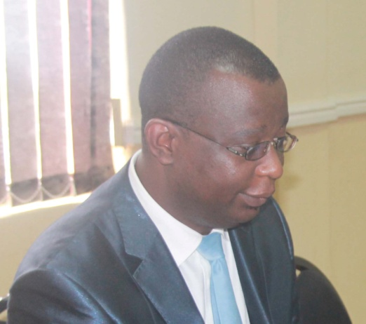

Dalitso Jumbe, currently working for Malawi Communications Regulatory Authority (MACRA) as Human Resources Manager. He has over 18 years in the management and administration of people. He has worked with various organizations in the sectors of communications sector in both Government and private sector. Dalitso has a Masters Degree in Leadership and Change Management, a Post graduate Diploma in Human Management Studies, and a Bachelors Degree in Human Resources Management. He is married with one child.

