Jonathan Peter Mwakijele, BSc (UDSM), MCM (KIST), MSc (Coventry)
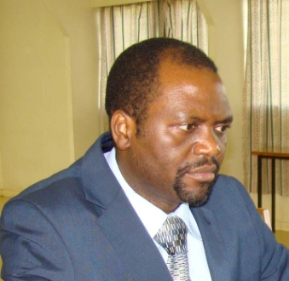
Jonathan Peter Mwakijele is the Head of Training, Consultancy and Research Unit at the African Advanced Level Telecommunications Institute (AFRALTI) in Nairobi, Kenya since 25th April 2013. He is also serving as Manager of Fiber Optics Academy. Before joining AFRALTI, he served the Kigali Institute of Science and Technology (KIST) as Lecturer and Head of Department, Computer Engineering and Information Technology. He has been a Programme Coordinator of Master of Communications Management (MCM) and Master of Science in Operational Communications (MOC) Programmes from 2007 to 2011 at KIST. From September to October 1997, he worked as Senior Lecturer at Soft-Tech Consultants Ltd, Dar es salaam, Tanzania prior to joining KIST, Kigali, Rwanda. He was awarded Bachelor of Science (Hons) with Computer Science degree from University of Dar es Salaam in 1996, Master’s Degree of Communications Management (MCM) at KIST in 2006 and Master of Science in Engineering and Manufacturing Management (EMM) in 2008 at Coventry University, United Kingdom (UK).
From 2009 to 2012, he has been representing KIST in the International Telecommunication Union (ITU) Steering Committee Meetings of Centers of Excellence (CoE) Network for Africa. Apart from lecturing undergraduate and postgraduate students and administrative work in the Institute, from 1997 to 2008, he worked in the Information and Communications Technology (ICT) Center at KIST, the Center has been providing Internet and Email services to staff and students; and also a number of local and international organizations. He has attended and spoken in several Regional and International Forums and Conferences on ICT, E-Learning, Education and Human Capacity Development; in 2011, he spent two month to learn and understand more about Wireless Networking for Developing Countries at the Abdus Salam International Centre for Theoretical Physics (ICTP), Trieste, Italy. He is a qualified Wireless Networking Trainer for Developing Countries. He is also a qualified e-Learning trainer.
Since October 2013, he has been chairing East African Communications Organization (EACO) Human Resource Committee meeting with mandate of two years.
Email: Jmwakijele@afralti.org

