Patricia Kerretts – Kemei (Mrs.)
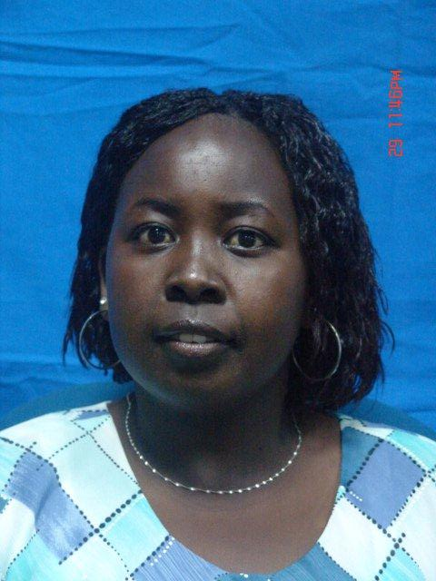

Mrs. Patricia Kerretts -Kemei is a Human Resource Professional having practiced for over 10 years and is currently the Manager/Talent Management & Organization Development at the Communications Commission of Kenya. She is also a Workplace Counselor and coordinates wellness activities on employee health.

Patricia has been involved in the area of Employee wellness, and has championed many initiatives at the workplace. She has also been involved in developing and influencing inclusion of curriculum on ethics and wellness in conjunction with the Ministry for State for Public Service and, Government Training Institute, under their Diploma Programme in Telecommunications Operations.

Patricia is a member of the Institute of Human Resource Management (IHRM), Kenya Institute of Management (KIM) and Alumni of the University of Nairobi Masters in Business Administration, and a Certified Ethics Officer under the Institute of Ethics (South-Africa). She also serves as a Board member of the Communications Sacco and Kamasai Education Center.

