Sam Matemba, foCi,
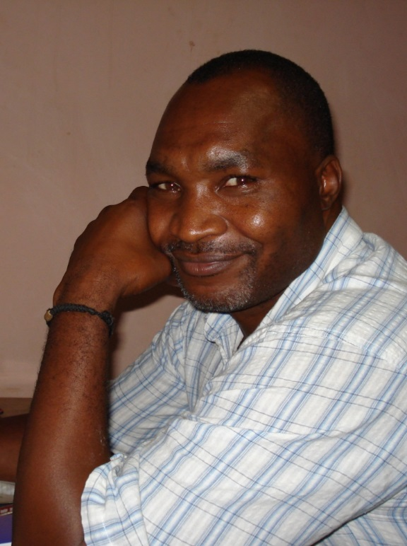
Sam has extensive experience in the Public and NGO sector having worked for 10 years at Operational, Director and Board level. A trained Civil Engineer, he gradually changed career paths after seeing the need for sustainable and successful organisations in Malawi. He is a professionally trained Organisation Development and Change Consultant and has run his own consultancy firm (foCi) for the past 10 years. Sam designs and facilitates diverse interventions, such as Workshop Facilitation; Organization, Programme or Project Reviews; Leadership and Team Development; Institutional and Capacity Development Needs Assessments & Planning; Strategic Planning; and Job Evaluations.
Sam is motivated and committed to improving the capacity of individuals, groups and organizations to provide quality service. He strongly believes that the sustained success of his clients in achieving their purposes and goals is heavily contingent on awareness of, and ability to manage change needs. This is why his intervention approaches are strong on methods that facilitate client-systems to gain control and confidence in managing the process of change from within. Sam is strongly committed to tailoring services to meet the organization, group or individual’s identified needs in ways that reinforce personal initiative, responsibility and independence rather than reliance on external elements.

