****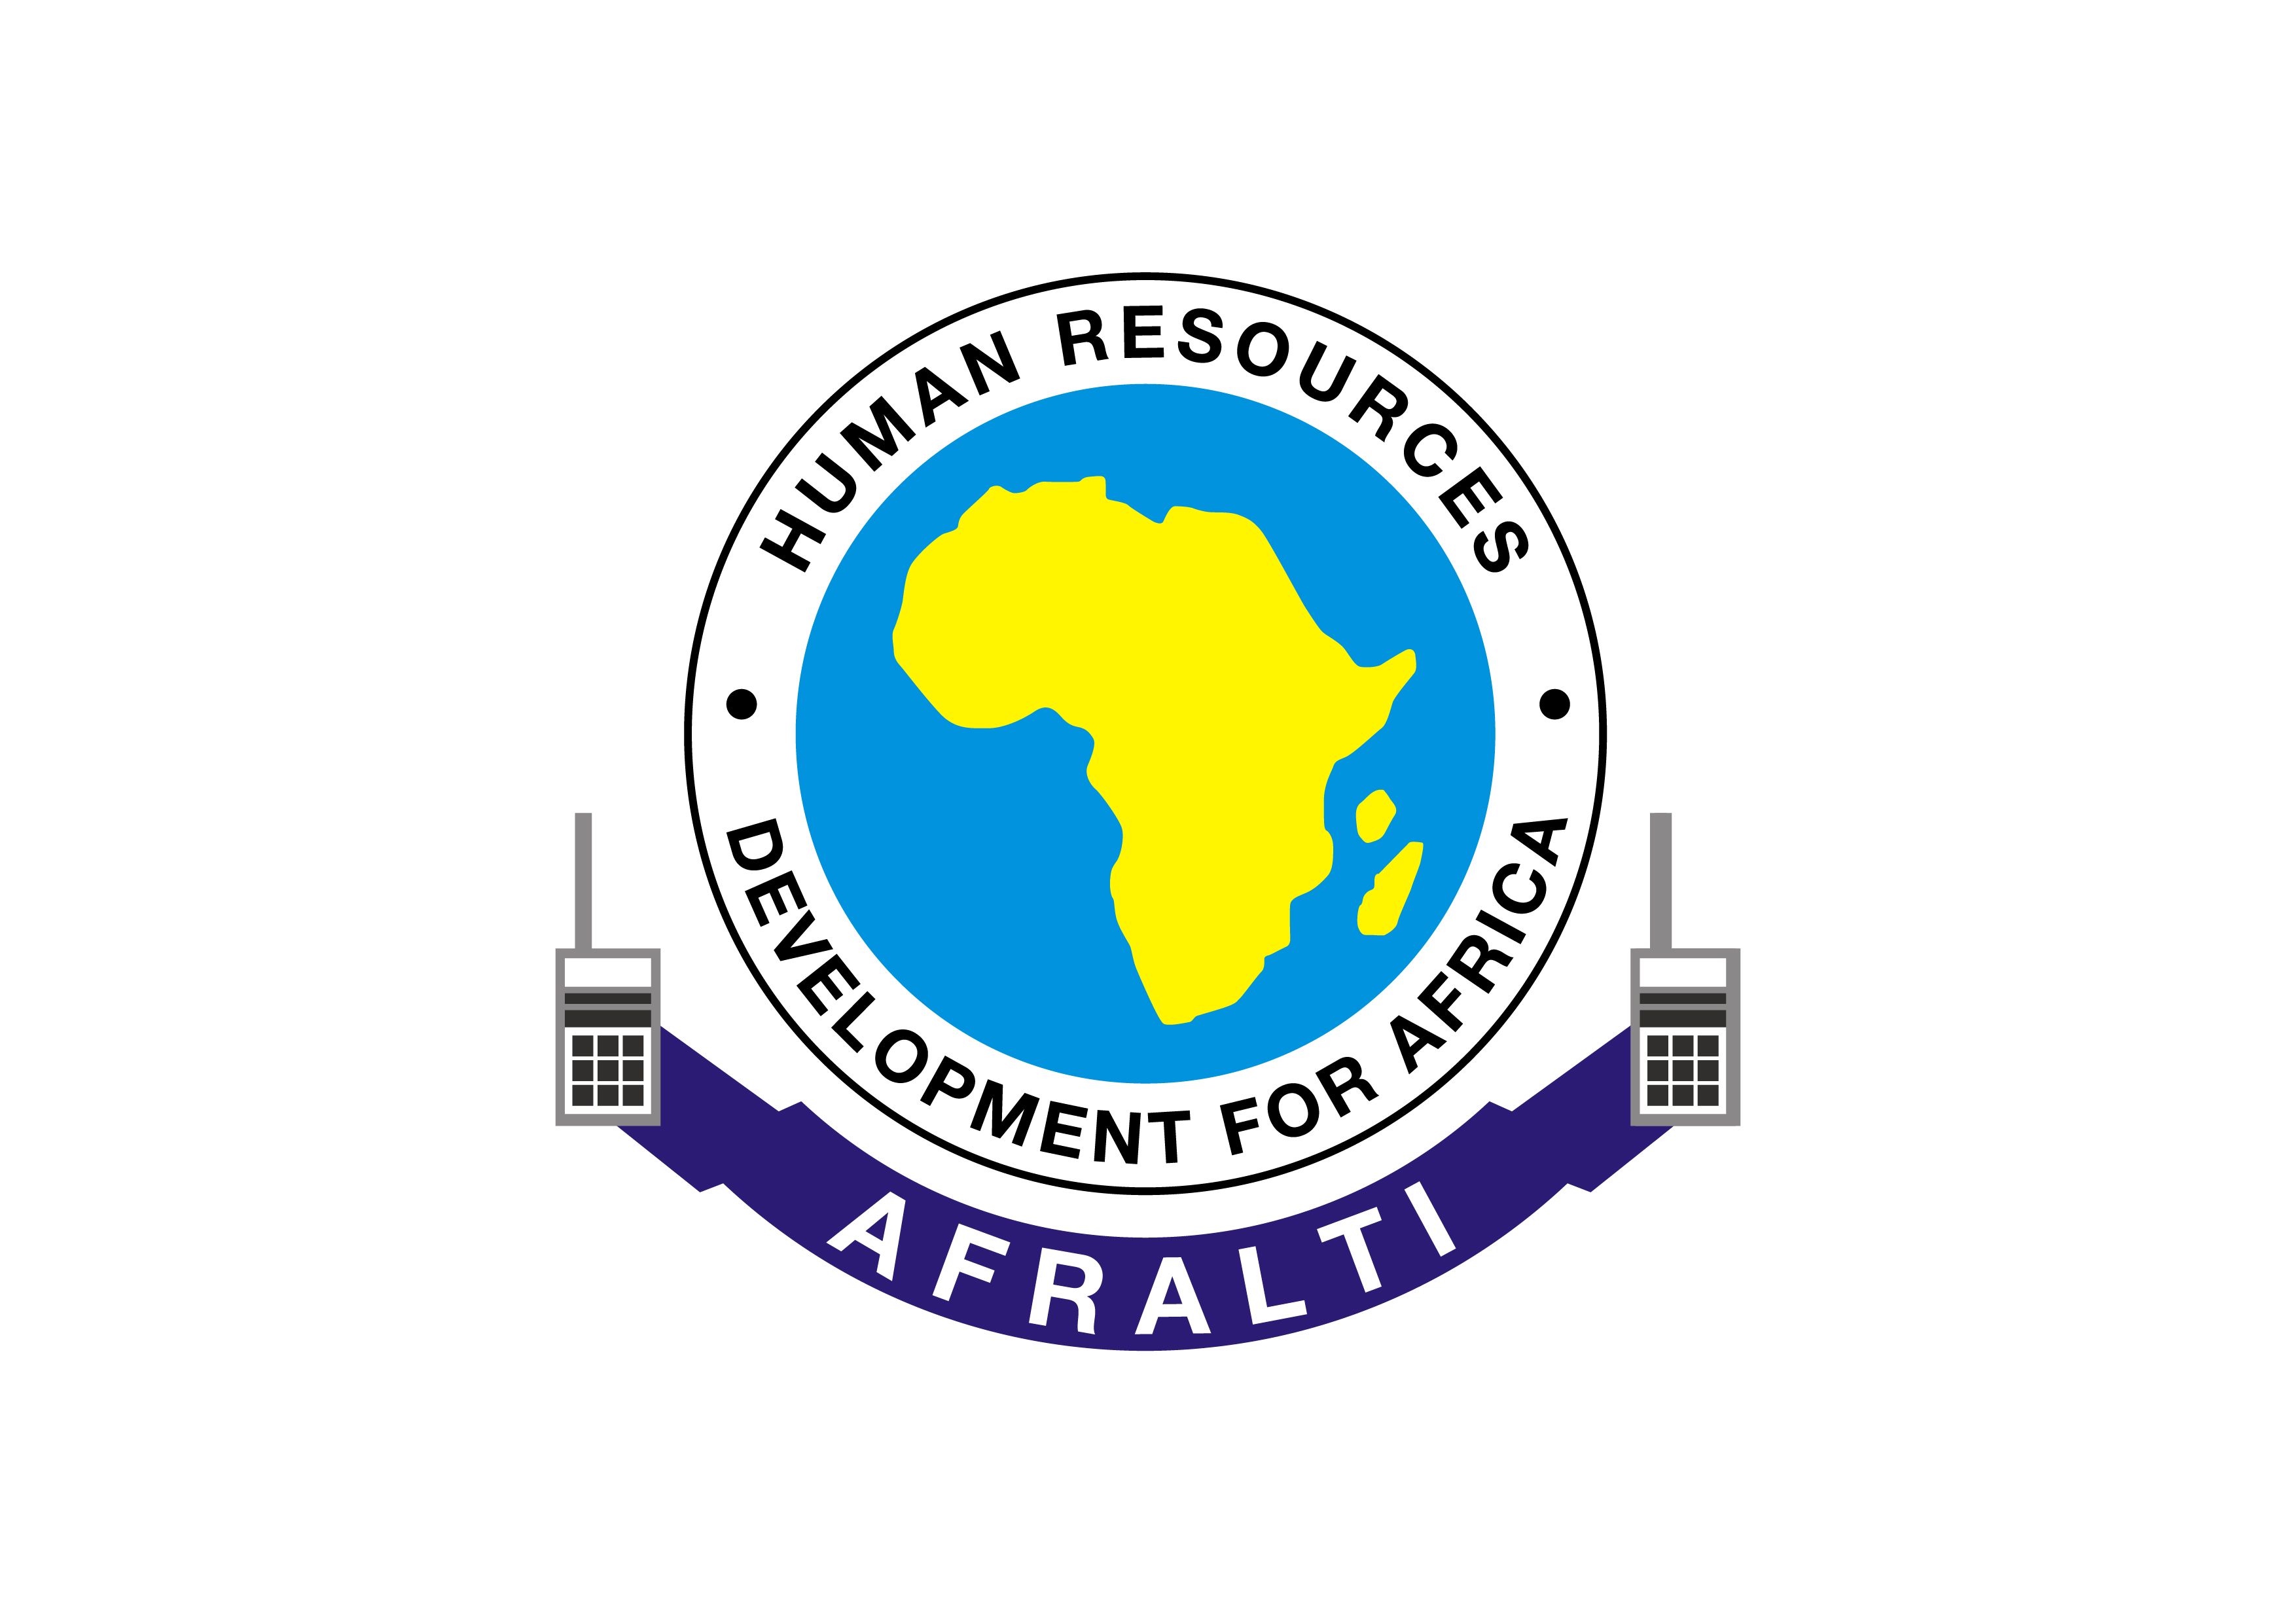 

**CAPACITY BUILDING ON CHILD ONLINE PROTECTION**

**TRAINING programMe FOR cop**

**DURATION: 4 WEEKS**

**THEME: *“HUWEZI TUCHEZA; TUKO CYBER-SMART”***

**VENUE: ONLINE (ZOOM & AFRALTI ONLINE ACADEMY)**

­­­­­­­­

|  |  |  |  |
| --- | --- | --- | --- |
| COP VIRTUAL TRAINING PROGRAMME | | | |
| DAY | **SPEAKER/PLATFORM** | **TOPIC** | **TIME** |
| DAY 1: | AFRALTI | * **Opening ceremony** * The impact of evolution on online behavior * Social Interaction and Behavior Acquisition | 11:00am-11:45am  11:45am- 01:00pm |
| DAY 2: | ICMEC | * Digital Identity/ Responsible digital Citizenship * Online Crimes * Internet Addiction | 11:00am- 01:00pm |
| DAY 3: | AFRALTI Online Academy | * Self-paced training * Quizzes and discussions | Open |
| DAY 4: | CYBERSPEAK PLC | * Emerging Issues on WWW * Online Environment- Appropriate/ Inappropriate | 11:00am- 01:00pm |
| DAY5 & 6: | AFRALTI Online Academy | * Self-paced training * Quizzes and Discussions | Open |
| DAY 7: | Diversity, Disability & Inclusion Specialist | * The Online life of a Child with Disabilities (CWDs) * Online Abuse of CWDs * Importance of Internet and Tech for CWDs | 11:00am- 01:00pm |
| DAY 8: | AFRALTI Online Academy | * Self-paced Training * Quizzes and discussions | Open |
| DAY9: | AFRALTI | * Cybersecurity * Network Security | 11:00am- 01:30pm |
| DAY 10 & 11: | AFRALTI Online Academy | * Self-paced training * Quizzes and Discussions | Open |
| DAY 12: | Kenya Law Reforms Commission | * Legal Aspects of COP * Children’s Act * Constitution &International Laws | 11:00am- 01:30pm |
| DAY 13: | AFRALTI Online Academy | * Self-paced training * Quizzes and Discussions | Open |
| DAY 14: | Directorate of Criminal Investigation | * Law enforcement in Children cases * Case Scenarios | 11:00am- 01:00pm |
| DAY 15 & 16: | AFRALTI Online Academy | * Self-paced training * Quizzes and Discussions | Open |
| DAY 17: | META | * Social Media management * Security on social networking platforms | 11:00am-01:00pm |
| DAY 18: | AFRALTI Online Academy | * Self-paced training * Quizzes and Discussions | Open |
| DAY 19: | Office of Director Public Prosecution | * The Courtroom Experience * International Cooperation and reporting procedures | 11:00am- 01:00pm |
| DAY 20: | AFRALTI Online Academy | * Quizzes   Participants’ Feedback | Open |
|  | **Closing Ceremony**  AFRALTI/ CA Team. | * Opening Remarks * Communication Authority of Kenya * Closing Remarks (AFRALTI) * List of Qualified participants, * Instructions on certificate pick-up. * Closing Prayer | 11:00am- 12:00pm |